Wheelchair Pre-approval Form
This is a pre-requisite form provided upon request for a wheelchair in conjunction with:
- Updated medical report along with clear recommendations
- Form to be filled by Rehabilitation consultant/specialists, Occupational therapist and physiotherapist.
- Please make sure the copy of these approval forms is always maintained in patient records for future references.
Failure to provide information relevant to approval will delay the processing of the applicant’s request. The provider will be contacted in case further clarifications are required.

MEMBER INFORMATION
Member Name: ________________________________________________________________________

Member Card #: _______________________________________________________________________

Policy: _______________________________________________________________________________

Date of Birth / /

Age (years): ___________

Gender: Female Male

PROVIDER INFORMATION
Ordering Provider Name:_______________________________________________________________

Ordering Clinician (ID & Name): _________________________________________________________

Performing Provider Name: _____________________________________________________________

Performing Clinician Specialty (ID & Name): ________________________________________________

Date of performing clinician review (DD/MM/YY): ____________________________________________

Performing clinician signature: ____________________________________________________________
Patient/legal guardian signature: __________________________________________________________
** Declaration: This assessment was conducted face-to-face

Medical History (Diagnoses/current medical issues/medications etc..)
__________________________________________________________________________________

__________________________________________________________________________________

__________________________________________________________________________________

__________________________________________________________________________________

__________________________________________________________________________________

Type of wheelchair requested
Power wheelchair Y / N  Power add-on  Power (electric complete)  Specify the justification of your selected choice:  ______________________________________  ______________________________________  ______________________________________  ______________________________________  ______________________________________ |  | Manual wheelchair Y / N  Standard  Bariatric heavy duty  Light-semi-active  Ultralight-active  Pediatric wheelchair or push chair (stroller)  Specify the justification of your selected choice:  ______________________________________  ______________________________________  ______________________________________

FUNCTIONAL STATUS
Does the wheelchair use require assistance: Independent Dependent

Hours/Day using wheelchair ______________________________________

Use of wheelchair: Short term long term

Observation required: Y / N

Ambulation status: (please specify if any device also used) __________________________________

Visual Scanning/Acuity/Fields: Intact impaired

Comments: _______________________________________________________________________

Hearing: Normal Impaired Deaf

Comments: _______________________________________________________________________

Communication: Verbal Non-verbal

Comments: _______________________________________________________________________

Cognition & Perception:

__________________________________________________________________________________

Psychological/Behavioural factors: _______________________________________________________

__________________________________________________________________________________

__________________________________________________________________________________

__________________________________________________________________________________

pressure injury? Y / N, If Yes then list where / when / stage: __________________________________

__________________________________________________________________________________
Impact on positioning in wheelchair: Seizures Spasm Oedema

Spasticity Respiratory Issues Swallowing Condition Contracture

Gastrostomy feeds Pain Obesity, please specify the BMI: ___________

Underweight, please specify the BMI: ___________ Bladder and bowel issue

Others/specify the details of the selected choice:

__________________________________________________________________________________

Upper Limb Function: (muscle strength/power/amputation etc): R side:

__________________________________________________________________________________

Upper Limb Function: (muscle strength/power/amputation etc): L side:

__________________________________________________________________________________

Lower Limb Function: (muscle strength/power/amputation etc): R side:

__________________________________________________________________________________

Lower Limb Function: (muscle strength/power/amputation etc): L side:

__________________________________________________________________________________

Additional information: _______________________________________________________________

__________________________________________________________________________________

__________________________________________________________________________________

WHEELCHAIR SPECIFICATION (measurements in cm/inch)
Frame: _________________________________________________________________________

Armrest: ________________________________Cushion: ________________________________

Seat Length: ________________________________ Seat Width: __________________________

Rear Wheels:______________________________________________________________________

Front Wheels: ____________________________________________________________________

Brakes: _________________________________________________________________________

Axles/Axle Plate: __________________________________________________________________

Backrest Height: __________________________________________________________________

Back Seat Height: _________________________________________________________________

Height: __________________________________________________________________________

Hanger Length: ____________________________________________________________________

Total W/chair Width: ________________________________________________________________
Seat Length: _______ Seat Width: _______

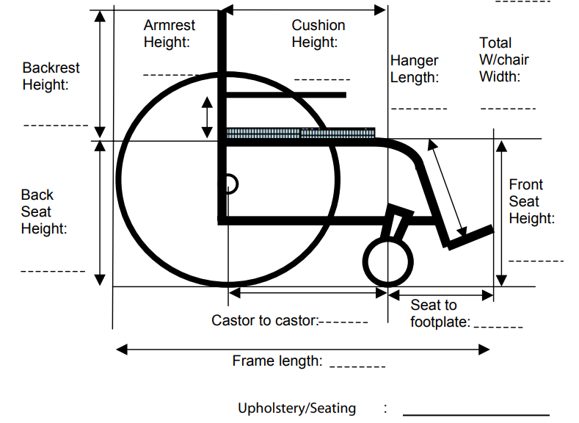

Options: Headrest Anti-tip bar & roller Tilting bars Carry bag

Stump support Clothes Guards Oxygen bottle carrier IV pole

Tilt in space: manual / electric ____________________________________________

Tray Straps/belts: ______________________________________________________

Recline: manual / electric: _______________________________________________

Others:

__________________________________________________________________________________

__________________________________________________________________________________

__________________________________________________________________________________

__________________________________________________________________________________

__________________________________________________________________________________

__________________________________________________________________________________

__________________________________________________________________________________

Know Your Wheelchair (KYW):
Wheelchair Order Form - For customized wheelchairs

Benefits:

- Understand the standard default items that comes with the main unit.
- Identify additional accessories and their costs (most wheelchairs include standard accessories at no extra charge).
- Prevent abuse by requesting an LPO and wheelchair order form, which helps stop fraud and abuse.

ADDITIONAL NOTES:
__________________________________________________________________________________

__________________________________________________________________________________

__________________________________________________________________________________

__________________________________________________________________________________

__________________________________________________________________________________

